Contents

1. Introduction 5

1.1. Overview of Architecture, Engineering and Construction Industry 5

1.2. Technology Implementation in AEC Industry 6

1.3. Development of AEC Industry under Smart City Paradigm 8

1.4. Scope of Research 9

1.5. Statement of Ethics 9

2. Literature Review 10

2.1. Overview 10

2.2. Control Room 10

2.3. Application of Digital Twin Paradigm 11

2.4. Digital Twin in AEC Industry 11

2.5. Research Gap 12

2.6. Features of Digital-Twin based Control Room 13

2.6.1. Information Management 13

2.6.2. Visualisation – Immersive Virtual Reality 13

2.6.3. Visualisation - Dashboard 14

2.6.4. Connectivity 14

3. Methodology 15

3.1. Research Method 15

3.2. System Architecture of the Control Room 15

3.2.1. Data Layer 16

3.2.2. Data Services Layer 16

3.2.3. Application Layer 16

3.3. Source of Data 17

3.3.1. Model Data 17

3.3.2. Project Performance Data 17

3.3.3. Sensor Data 18

3.3.3.1. Field Condition 19

3.4. Information Management 20

3.4.1. BIM 360 20

3.4.2. Microsoft Azure 22

3.4.2.1. Database Management 23

3.4.2.2. Streaming of Sensory Data 24

3.5. Data Visualisation 25

3.5.1. VR 25

3.5.2. Dashboard 26

3.6. Connectivity 27

3.7. GitHub Repository 27

4. Result & Discussion 28

4.1. BIM360 28

4.1.1. Document Management 28

4.1.2. Design Collaboration 29

4.1.3. Project Management 30

4.1.4. Limitations 31

4.2. VR 33

4.2.1. Project Perception 33

4.2.2. Safety Hazard Identification 34

4.2.3. Limitations 35

4.3. Dashboard 37

4.3.1. Identify Insight from Safety Record 37

4.3.2. Monitoring the Working Environment 39

4.3.3. Limitation 39

4.3.4. Recommendation 40

4.4. Connectivity with External Applications 41

4.4.1. Challenges 41

4.4.2. Recommendation 42

4.5. Day-to-Day Routine of Control Room 43

4.6. Future Development 44

5. Conclusion (300 words) 45

6. Reference 47

7. Research Log 49

8. Appendix 50

**List of Figures**

Figure 1 McKinsey Global Institute industry digitization index (McKinsey, 2015) 7

Figure 2 System Architecture of Control Room 15

Figure 3 BIM Model visualised in the Autodesk Revit 17

Figure 4 General Layout of the machinery to process the raw material 19

Figure 5 Sensor Box Set-up 20

Figure 6 Data Capturing during Operation 20

Figure 7 Control Room Home Page 21

Figure 8 Overview of modules in BIM 360 22

Figure 9 Azure IoT Ecosystem extracted from Microsoft Azure Cloud Service 24

Figure 10 Real-Time Metrics from Azure Stream Analytics 24

Figure 11 Comparing the difference between models by BIM 360 Document Management 28

Figure 12 Overview of BIM 360 Design Collaboration Module 30

Figure 13 RFI form from BIM 360 31

Figure 14 Different Team member immerse in a 3D environment 33

Figure 15 Identifying Safety Hazard 35

Figure 16 Overview of Prospect 36

Figure 17 Layout of Water Treatment Structure of a project located in Liverpool 36

Figure 18 Dashboard Visualisation by Power BI - Overview 37

Figure 19 Dashboard Visualisation by Power BI – Tree Diagram 38

Figure 20 Line Chart Visualisation of Sensory Data by Power BI 39

Figure 21 Overview of Viewer Application 41

**List of Tables**

Table 1 Technical Specification of Raspberry Pi and Sensors 18

Table 2 Table Summary of Safety Data in SQL Server Database 24

Table 3 Table Summary of sensor data in Power BI 25

Table 4 Specification of Oculus Quest 26

# **Introduction**

# **Overview of Architecture, Engineering and Construction Industry**

The Architecture, Engineering and Construction (AEC) industry is one of the largest industries in the global economy. About $10 trillion are spent on construction-related activities over the world annually, which is equivalent to 13 per cent of the world’s GDP. There is also 7 per cent of the labour force around the world are working in this industry (McKinsey & Company, 2017). However, the productivity of the AEC Industry is lagging the global productivity by over 30% and 98% of infrastructure projects are over budget or delayed around the world (Changali *et al*., 2015).

The project delivery practice among the project members is commonly known for poor in collaboration such as working with a silo mentality and inadequate coordination (Richard, 2018). As the AEC industry is complex and dynamic (Mohd Nawi *et al*., 2014), it consists of multiple disciplines at various stages such as planning, design, construction, and operation. The personnel in these disciplines can range from structural, building services, civil and mechanical engineering teams as well as architects who are involved from the beginning until the completion of a construction project. A construction projects can involve thousands of work tasks which are interrelated, one individual task not managed properly could significantly impact the quality and productivity of the works in future stages.

Another issue is that information management in construction is not effective enough. The AEC Industry is labour-intensive and generates enormous amounts of information including calculation, drawings, project reports, tender documents, etc which are produced as part of a construction project. Research in China (Xu & Luo, 2014) has identified and discussed many consequences on the poor collaboration and information transfer among different parties, such as the loss and inconsistency of information caused by fragmentation of parties and unorganised information systems. A comprehensive statistic of two typical sites in middle and north China shows that around 43%, 12%, 3% of the project time is lost due to inconsistent information, dislocation, and ambiguity respectively on a construction project in average.

Health and safety deficiency are also the main concerns as compared to other industries. The AEC industry has long been recorded with the highest number of death and accident rate compared with other industries globally. About 79,000 workers in the construction industry in Great Britain suffered from work-related ill-health such as depression and musculoskeletal disorders and 30 fatal injuries in 2019 (HSE, 2019) about 62% of construction workers are suffering from musculoskeletal disorders. The rate is significantly higher when compared with the rate for workers across all other industries, which is only at 1.2% [ibid].

# **Technology Implementation**

The AEC industry is far behind to adopt new technology compared with other industries. The digitization index which measures the adoption of technology in different industries, it shows that the construction industry is very low as shown in Figure 1(McKinsey, 2015). The reasons for the slow adoption might lead to high cost and slow return by using technology, lack of technical expertise to maintain the technological solution, lack of training. Another report (Global Construction Survey, 2019) by KPMG, the majority of participants acknowledged the importance and impact of technology and innovation in construction, however, only few companies were adopting it significantly, and even omitted its benefits.

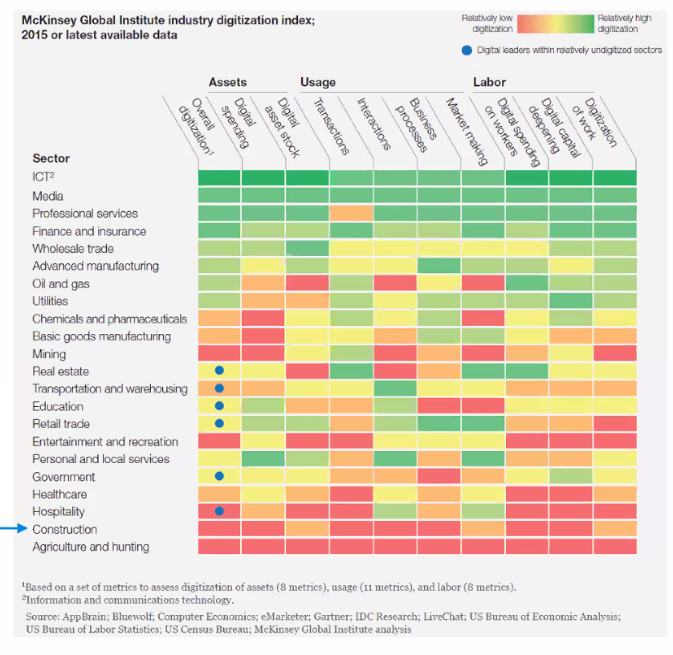

Figure 1 McKinsey Global Institute industry digitization index (McKinsey, 2015)

As projects are ever more complicated, involved more parties. larger in scale and the shortage of skilled labours and supervisory staff are getting worser, there is a growing demand for using technology to improve the project delivery. These are important issues that require new ways of thinking and form of working to improve the situation (ibid).

Besides, the explosion of global pandemic COVID-19 triggered the development of digital transformation in different industries (Chhaya *et al*., 2020). With unprecedented consequences such as the disruption of manufacturing and supply chains, the mitigation to the impact by COVID-19 requires a new approach of working and forms of collaboration to increase the overall resilience of the business with technology.

# **Development under Smart City Paradigm**

Nowadays, the development of smart city is the fundamental basis of our city. The smart city framework focus on integrating all these systems effectively with linking the interrelationships between multiple city systems such that technology can be used effectively (Cosgrave, 2017). Besides, there are three elements highlighted for smart cities (Harrison et al., 2010), which are instrumented, interconnected and intelligent. Instrumentation means capturing the data from the physical world by sensors; interconnection means the data should be integrated from different source and they can communicate each other, while intelligent means the data should be visualised and provide insight for making better decision.

On the side of policy, the technology should be implemented with citizen-focused (Lara *et al*., 2016). The developer must understand their citizens need and develop appropriate technologies which will be beneficial to them. This citizen-centric value defines the initiative Project 13 in the AEC industry, which aims to develop a new business model for delivering high performing infrastructure to the ultimate user (i.e. the citizen). There is an ‘Integrator’ character which can be a single company or a collective party who plans and delivers the infrastructure programme, manages the suppliers and advisors, oversees the design, construction, maintenance and operations as requested by the owner (Institution of Civil Engineers, 2018). Most importantly, it pointed out that the Integrators should bring together capabilities to deliver effective solutions through production systems and enables a platform approach to deliver the project stipulated under the “Integration” pillar of the five pillars in the initiative (ibid). Regarding this, an integrated platform such a Control Room should be considered to improve the project delivery in the AEC industry.

# **Scope of Research**

This study aims to explorer the effectiveness of using the Control Room in the AEC industry. The research questions of this study are as follows:

* Explore the features of the Control Room in the AEC industry
* Explore how these Control Room features to enhance the project delivery for the AEC Industry
* Explore the improvement of these Control Room’s features

# **Statement of Ethics**

All the data used in this study do not contain any personal information. Therefore, no ethics approval was required.

# **Literature Review**

# **Overview**

First, the technological basis of the Control Room will be reviewed based on the historical application. It shows that it is pairing technology, which is the precursor to the digital twin paradigm in the fourth industrial revolution nowadays. Followed by some example to illustrate how to make use of this digital twin paradigm in the product manufacturing industry, it shows that the AEC industry has similar nature with manufacturing industry and can make use this paradigm to improve the working process and project delivery. Accordingly, the features of the Control Room have been outlined based on the conceptual framework of digital twin paradigm summarised from the literature.

# **Control Room**

The technological basis of the Control Room can be traced back to the old days. In the 1920s, the Control Room aimed at production control and monitoring the physical facility in a central space (Bennett, 1993). In the 1970s, the launch of the Apollo 13 program by NASA made use of the Control Room for monitoring the outer space condition (Jarrett, 2020). The engineers on the ground Control Room needed to respond swiftly the changes in the space vehicle and the astronauts being exposed to extreme conditions in outer space. Later, NASA identified that they can no longer make decisions to tackle the problems immediately based on the original modelling method because the actual module had been subjected to significant changes due to the exposure under an extremely hostile environment. It was necessary to update the original modelling method so that the actual state of the module could be closely simulated. As a result, they used the “pairing technology” which is the precursor to the digital twin paradigm to simulate the outer space with mathematical models so that engineers and other professionals could collaborate in the Control Room on the ground and made decision-based on mathematical models.

# **Application of Digital Twin Paradigm**

The following examples show how digital twin paradigm works in the product manufacturing industry. A digital-twin based production management and control system has been used for complex products development (Yi *et al*., 2020). The product digital twin acts as a single data source to support the collaboration between vendors throughout the product lifecycle, which are product design, process planning, product assembly, product use and maintenance.

Besides, during the life cycle, the enormous amount of shop-floor data can be visualised and integratory managed based on digital twin approach. Take the assembly stage as an example, the assembly shop-floor digital twin is composed of shop-floor production elements’ geometric models to represent the physical models such as shop-floor model, production line models, assembly station models, manufacturing resource models, product models, and environment models (Zhuang *et al*., 2018). And they contain full element assembly process information and assembly process data, which are the same as physical assembly procedures, it facilitates the cyber-physical integration of the product assembly process.

Another technology is Internet of Things (IoT) that has also been used to ensure the timeliness demand in manufacturing/assembly shop-floors. For example, the real-time information acquisition, material delivery, work-in-progress (WIP) management, product quality monitoring, manufacturing cost tracking, adaptive production process control can be achieved to ensure the product delivery (Zhuang *et al*., 2018).

# **Digital Twin in AEC Industry**

The Control Room in the AEC industry can also make use of the digital twin paradigm to enhance the project delivery as It has similar nature with the product manufacturing industry. The infrastructural projects generate an enormous amount of data during the entire project life cycle and It involved multi-discipline teams for collaboration in the projects. Many professionals have already suggested that Building Information Modelling (BIM) should play an important role with the digital twin to form an integrated approach (Boje *et al*., 2020), as it utilises a 3D model to simulate the building or infrastructure and store various types of information during the entire life cycle. As a result, a digital twin-based Control Room can also be developed to enhance project management and reduce risk like project delay, over-budget and minimise contractual implication and safety deficiencies in the AEC Industry.

Besides, the CDBB’s Digital Framework Task Group (DFTG) has introduced the National Digital Twin (NDT) programme in the infrastructure and construction sectors (Bolton *et al*., 2018). It focused on creating an ecosystem of digital twins which connected each other with securely sharing of data, it could increase the infrastructure resilience by minimising disruption and delays, optimising the use of resources and boost the quality of life for citizens.

Based on the similarity between the product manufacturing industry and AEC industry, it shows that the conceptual framework of the digital-twin based Control Room in the AEC industry can be implemented as follows. First, it should be a platform which can enhance information management and collaboration. Second, it should include digital models paring with the physical facility with the help of IoT device and the data obtained can be visualised and analysed. Third, the system should be able to exchange data with other digital systems.

# **Research Gap**

To explorer how the features of the Control Room to enhance the project delivery, only with the conceptual framework summarised by literature is not enough. There is less research on how to implement these features practically with using a case study to show how does it work in the AEC industry. This study will try to fill this gap and explorer the following features of a digital-twin based Control Room based on the framework discussed on the last session.

# **Features of the Digital-Twin based Control Room**

# **Information Management**

It should be a platform to foster collaboration and information exchange between different disciplines. Traditional tools such as email, project management software and telephone are just one-way communication activities. They lack real-time collaboration elements which are for connected engagement, discussion and approval process (Levine, 2016). If different parties in the project can submit updates of information on a simple and real-time manner on a single platform to create a single source of truth (i.e. common data environment), it will be easier for all project team members remain on the same pace as the project proceeds, so it would not make the progress delay in terms of scheduling and over-budget due to rework.

Since diﬀerent types of sensors would be installed on the real system, it is essential to use a high-power computational service that represents models for their interactions. One of the solutions is to use a cloud service that oﬀers high ﬂexibility and high processing performance. Cloud computing changes the traditional way of businesses to manage IT resources, which the services such as servers architecture, databases, analytics, business intelligence over the Internet and ensuring data security (Microsoft, 2020). Cloud Computing also eliminates the requirement of using local hardware to handle and process data, thus no need to pay extra cost to buy hardware with high computation power (Stergiou *et al*., 2018). Therefore, this platform should be cloud-based so that it saves cost and with high computation power.

# **Visualisation – Immersive Virtual Reality**

Immersive Virtual Reality (VR) can give the user feel like physically presenting in a computer-generated environment simulating places in the real or imagined worlds. It is commonly used in the education and training purpose by its potentials to provide an interactive and motivated environment (Freina & Ott, 2015). Besides, many publications have identified various areas that VR technologies have been implemented to enhance safety (Alizadehsalehi *et al*., 2019), such as risks identiﬁcation, workforce training, skill transfer and ergonomics in the AEC industry (Li *et al*., 2018). While VR can also be used for meeting with team members to work together within a 3D model for discussion, which is a benefit for remote working (Brandon, 2020). All of the above literature showed that VR device is an effective tool for enhancing the interaction between human experiences and building environments.

# **Visualisation - Dashboard**

Dashboard visualisation is a cognitive tool to improve our “span of control” over the business data (Toasa *et al*., 2018). This helps the managers to identify trends, patterns, and anomalies from the data. Managers can figure out the reason for what they observe and as a guideline for them to make effective decisions. Besides, Key Performance Indicators (KPIs) is commonly used to evaluate the outcomes of interventions to similar data from before the interventions (Voordt, 2017). The project members can make use of this to improve the building processes and risk identification. It is the topmost priority for Project Directors, Project Managers and any other person responsible for planning management to implement a better planning process by having a clear view of the project’s status.

# **Connectivity**

A digital twin platform should allow the system to interact with other digital twins such that these systems can be connected and scalable. To achieve this, the Control Room platform should provide open Application Program Interfaces (API) such that the more user can utilize the function of the Control Room platform and third-party developers can develop external applications. It motivates more developers to improve the functionally of the entire Control Room system and make good use of the data.

# **Methodology**

# **Research Method**

Based on the features discussed in the last session, some available services and software to demonstrate these features have been selected to form the system architecture of the digital-twin based Control Room. A case study of the residential house design and built project[1] will be used to explore how these Control Room features to improve the project delivery and any improvement on it.

# **System Architecture of the Control Room**

The service and software available in the market have been allocated into different layers of the system architecture for the Control Room as Figure 2. It composed of three layers which are the Data Layer, Data Services and Application layer.

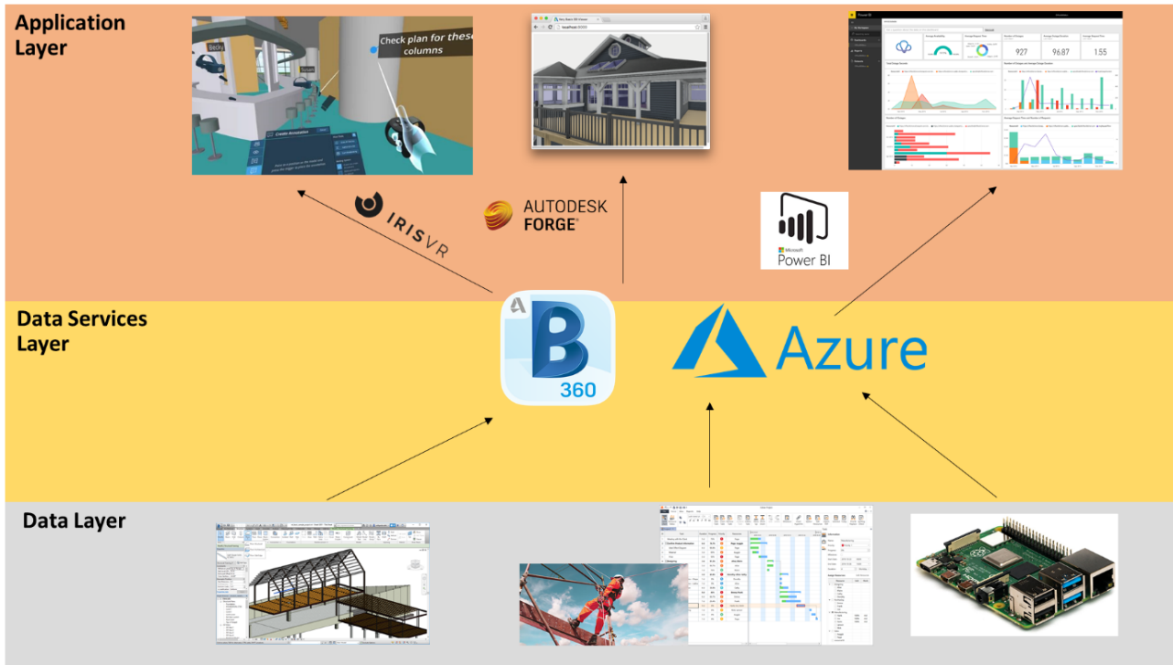

Figure 2 System Architecture of Control Room

# **Data Layer**

Each of the component (from left to right of Figure 2) in the data layer is used to represent different aspect of the construction site.

* Model data: the digital model of the physical configuration of the building
* Project performance data: Safety data
* Sensory data: The environmental condition of the construction site

# **Data Services Layer**

This layer demonstrates the information management feature of the Control Room. The model data will be published to the BIM 360 cloud platform for collaboration so that different project team members can modify the model data remotely on a single source of environment. Besides, Microsoft Azure Services provide a platform with different tools for establishing server-side application to process and storage the data. The project performance data and sensory data will be inserted in a SQL Server database and dataset for Power BI which are created with Azure Services respectively. All these data can be retrieved to feed into the elements in the application layer for visualisation. Details of these data services will be discussed in Section 3.4 and 3.5.

# **Application Layer**

The application layer demonstrated the data visualisation and connectivity features of the Control Room. Model data in BIM 360 will be visualised in the VR environment with the software “Prospect” developed by IrisVR. The project performance data and real-time sensory data will be visualised with the dashboard by Microsoft Power BI. While the Autodesk Forge API will be used to retrieve the data from BIM 360 to an external application which is a viewer application. Their details will be discussed in Section 3.6 and 3.7.

# **Source of Data**

All the data used in this study will be modified from different sources to fit into the novel of the case study of residential house.

# **Model Data**

The model data is a template file provided by Autodesk Revit 2020 with the format of “.rvt”. The 3D model can be visualised as Figure 3:

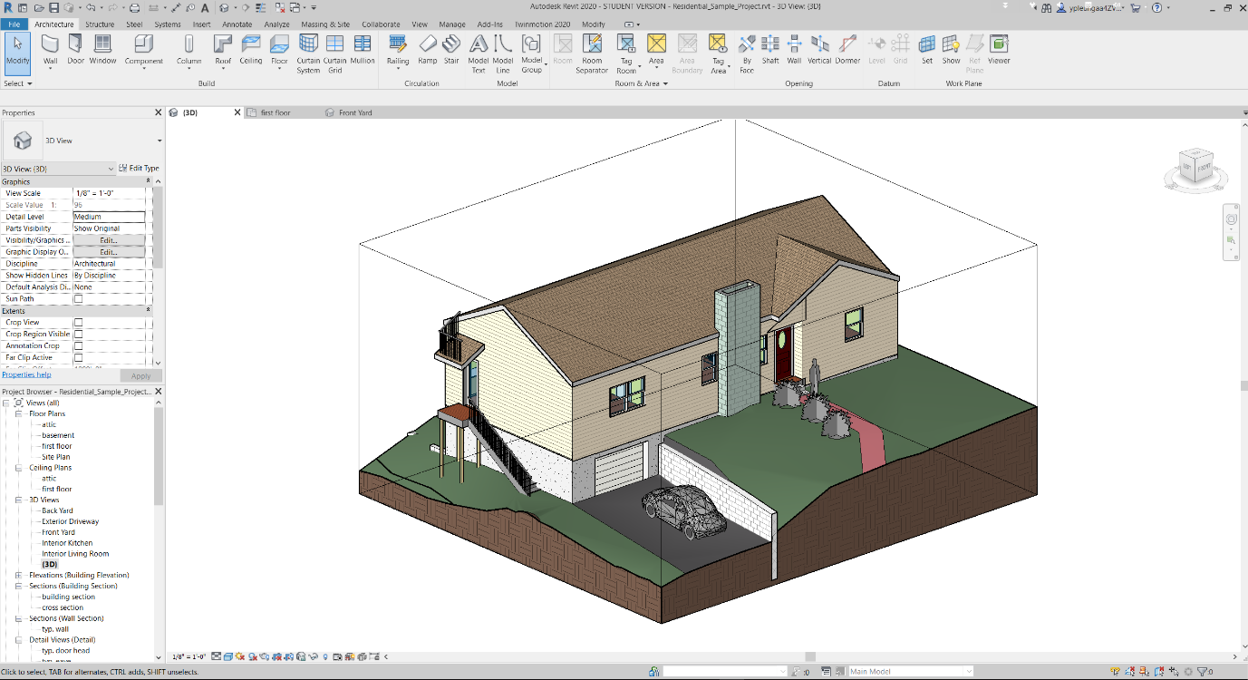

Figure 3 BIM Model visualised in the Autodesk Revit

The model contains objects data relating to the architectural and structural elements. All objects in the model contained information such as object name, type ID, furniture name, material information and major dimensions in object property. All the model data would be processed by Autodesk Revit first and would be published to BIM 360 online to simulate the collaboration features of the Control Room.

# **Project Performance Data**

One dataset of project performance data used for this study is modified from the data provided from the ‘Project Hack 5[2]’ hackathon organised by Project Data Analytics Community. It contains all incident record of the construction project of the residential house from 2016 to 2020, it includes detailed information with 139 rows and 15 columns, such as date of the accident, accident category, nature of injury and damage classification and type of contact.

# **Sensor Data**

Low-cost microcontroller Raspberry Pi (RPi) has been selected as the prototype of IoT devices to capture the environmental data. RPi is a Linux-based platform. It is a credit card-sized computer and can be as an alternative to a desktop computer. As it is low cost and support different operating systems, it is suitable for ranges of projects such as acting as an IoT device. The version used in this study is the Raspberry Pi 4 Model B which is newly released on the end of May 2020. The RPi can connect with local area networks with WIFI and transfer the data received from the sensors to Microsoft Azure IoTHubs services, which will be explained in Section 4.4.1. The technical specification are given in the below Table:

Table 1 Technical Specification of Raspberry Pi and Sensors

|  |  |  |  |
| --- | --- | --- | --- |
| **Component** | **Image** | **Relevant Technical Data** | |
| Raspberry Pi 4 Model B | Raspberry Pi® 4 B 4 GB 4 x 1.5 GHz Raspberry Pi® | Conrad.com | Cost:  RAM  Processor  Operating  Voltage | 68 pounds  8GB  Broadcom BCM2711, Quad core Cortex-A72 (ARM v8) 64-bit SoC @ 1.5GHz  5V DC via USB-C Connector (minimum 3A) |
| SHT20 | SHT20 溫濕度傳感器模組I2C 通訊- 台灣物聯科技TaiwanIOT Studio | Cost  Interface  Temperature Range  Humidity  Range  Operating Voltage | 3 pounds  I2C  -40oC to +125 oC  0 to 100%  3.3V |

# **Field** **Condition**

Under the disruption of COVID-19, it is hard to find an actual construction site for capturing the environmental data for this study. As a result, the sensory system had installed on a local factory which manufactures hangers in Hong Kong as Figure 4to simulate the working condition of a construction site and the ability of the sensor to collect the empirical data. The usable area of the factory is around 75 sq. feet and height 12 feet. One worker is working in this factory from 09:00 to 17:00 from Monday to Friday to keep on monitoring and maintaining the two machinery which produce hangers and process the raw material of hangers inside the factory. Although there is an indoor constraint of this location which is different from a typical construction site that usually located outdoor and subjected to the weather, the temperature and humidity of working environment will be impacted when the machinery are operating, it is still applicable to demonstrate the ability of the connectivity features of the Control Room. The data will be captured during the operation of the machinery that processing the raw material shown in Figure 4 to simulate the working condition of a construction site.

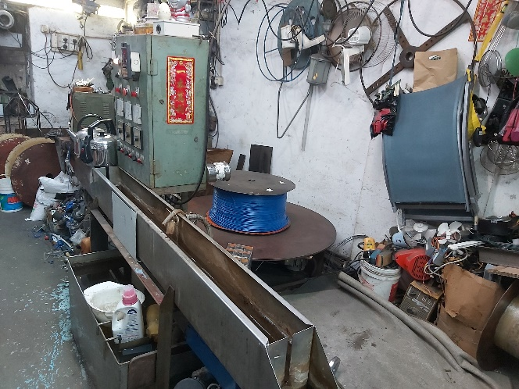

Figure 4 General Layout of the machinery to process the raw material

One sensor box has been set-up in Figure 5 and it will be installed next to the machinery shown in Figure 6 for capturing data. The data was captured from 18:19:00 to 18:23:00 on 22 August 2020.

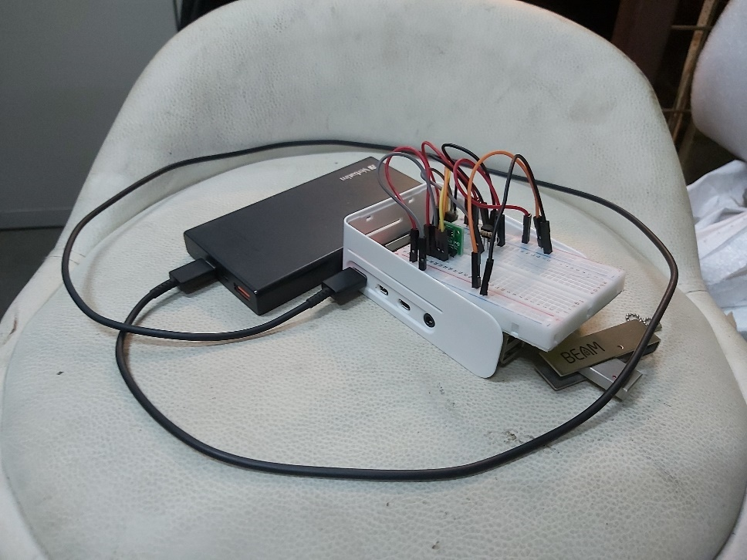

Figure 5 Sensor Box Set-up

Sensor Set-up

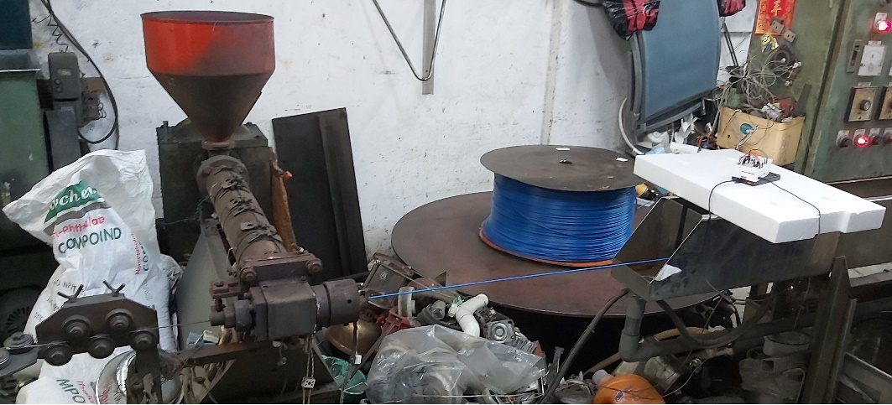

Figure 6 Data Capturing during Operation

# **Information Management**

# **BIM 360**

BIM 360 is a common data environment (CDE) and a collaboration platform. This service is cloud-based and developed with Amazon Web Service (AWS). This service has been used in this study since it is the only solution that provides a trial version for education purpose in the market.

On the “Project Home” page of this platform, it allows users to add different customised card such as the status of the project issue, RFI, model and even insert the Power BI dashboard, which provides a great integration capability to organise different kinds of information for the project members to read. A snapshot of the Project Home page is shown in Figure 7*.*

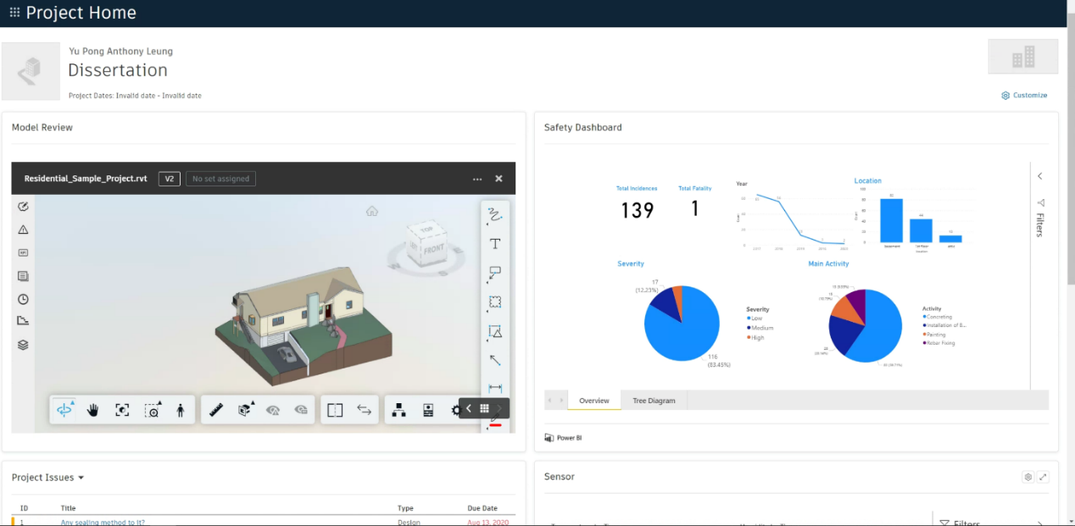

Figure 7 Control Room Home Page

Besides, this platform provides different modules as Figure 8 to enhance the collaboration of different parties and managed the information. The modules such as “Document Management”, “Project Management” and “Design Collaboration” will be used in this study. As a construction project contains lots of drawings and BIM model data, these documents will be stored in the module Document Management which supports version control. It also provides ways to keep track on every single step on the workflow approval. The Project Management module will be used to show how the Request For Information[3] (RFI) issued by different parties can be accounted for step by step and keep on monitoring to ensure they can be answered on time and with no ambiguity. Design Collaboration module will be used to show how BIM model packages is created by one team and how does another team to consume these packages for their further amendment on the BIM model.

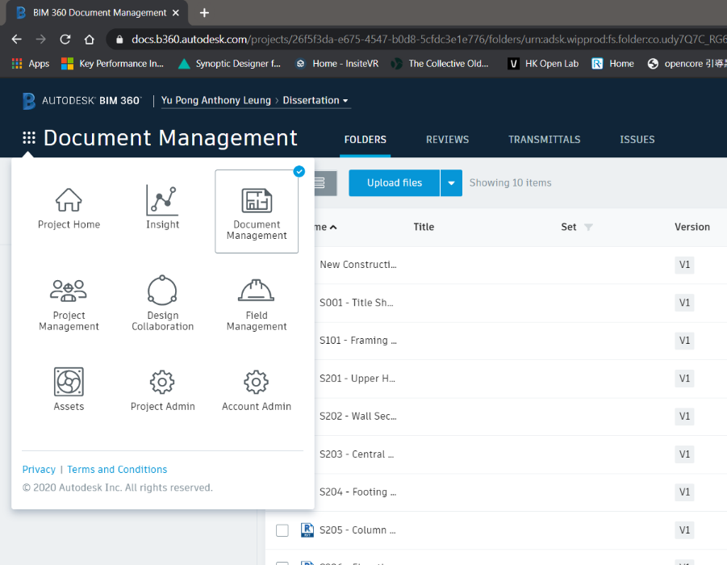

Figure 8 Overview of modules in BIM 360

# **Microsoft Azure**

Azure is used to demonstrating how it supports the information management and data visualisation features of the Control Room. It offers cloud service in three main categories: Infrastructure as a Service (IaaS), Platform as a Service (PaaS), and Software as a Service (SaaS). PaaS will be focused on this study. Platform as a service (PaaS) is a cloud-based development and deployment environment, with resources to deliver our applications.

PaaS not only includes the elements of IaaS such as servers, storage, and networking, it also provides middleware, development tools, business intelligence (BI) services, database management systems and so on. It is designed to support the full development of the lifecycle of a web application like building, testing, deploying, managing, and updating. Compared with another cloud service, the Azure provides a more user-friendly interface and many documentations available by Microsoft for the developer to build their application, the building blocks are clear to build the new application. Also, as Azure support directly push the real-time data to Power BI, which provides an easy way to set up real-time visualisation of sensory data.

Microsoft Azure cloud service is the only one in the market to offer a free tier one-year subscription for students, which is a great choice for this study.

# **Database Management**

Azure SQL Database is a fully managed PaaS database engine that handles most of the database management functions such as upgrading, patching, backups, and monitoring without user involvement. With Azure SQL Database, a highly available and high-performance data storage layer for the applications and solutions can be created. It also allows the process of both relational data and non-relational structures, such as graphs, JSON, spatial, and XML. The script was used to create a table in SQL Server Database and insert the dataset in .csv format from python to the table was attached in Appendix 1, it established a connection to the SQL Server with the required credentials to perform inserting to the database. Python Libraries such as ‘pandas’ and ‘pyodbc’ will be used for data processing and building connection with the SQL Server. The details of the safety data table have been summarised in Table 2.

Table 2 Table Summary of Safety Data in SQL Server Database

|  |  |  |  |
| --- | --- | --- | --- |
| **Table Name** | **Field** | **Type** | **Description** |
| SAFETY | activity | Text | As suggested by the field name |
| actual_closure_date | Date |
| ai_category | Text |
| body_part | Text |
| date_of_accident | Date |
| date_of_report | Date |
| id | Whole Number |
| investigation | Text |
| investigation_level | Text |
| location | Text |
| nature_of_injury | Text |
| no_of_days_lost | Date |
| target_closure_date | Date |
| type_of_contact | Text |

# **Streaming of Sensory Data**

For the sensory data, the sensor with the microcontroller Raspberry Pi (RPi) acts as a node and registered as an ‘IoT devices’ in Azure IoT Hubs. The python script attached in Appendix 2 has been executed on the RPi to connect with the IoT Hubs. RPi has set to send data every three seconds. By using the IoT Hubs services as the gateway, the data can be further processed with the Stream Analytics to push to other applications as Figure 9 referenced from the Microsoft Azure Cloud.

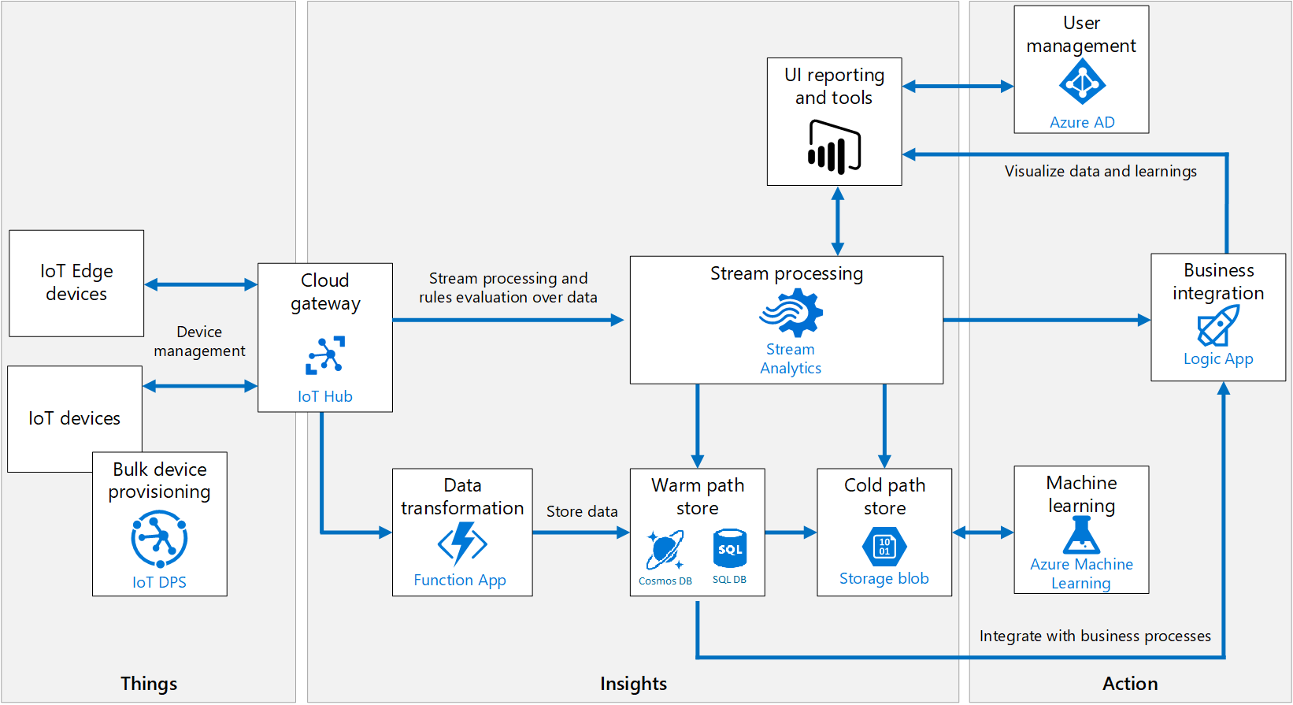

Figure 9 Azure IoT Ecosystem extracted from Microsoft Azure Cloud Service

Azure Stream Analytics is a real-time streaming engine that is designed to process high volumes of fast streaming data from multiple sources simultaneously. Once the relationships between input sources RPi in IoTHubs and output sources such as streaming as a dataset in Power BI has been formed, it will trigger the streaming of real-time sensory data from IoT device to Power BI. Figure 10shows the real-time metrics of the status during data streaming between the input source and output source. The blue line represents the volume of data at different time input from the Raspberry Pi while the red line represents the volume of data output to the power BI dataset. Four trial to capture the data has been carried out.

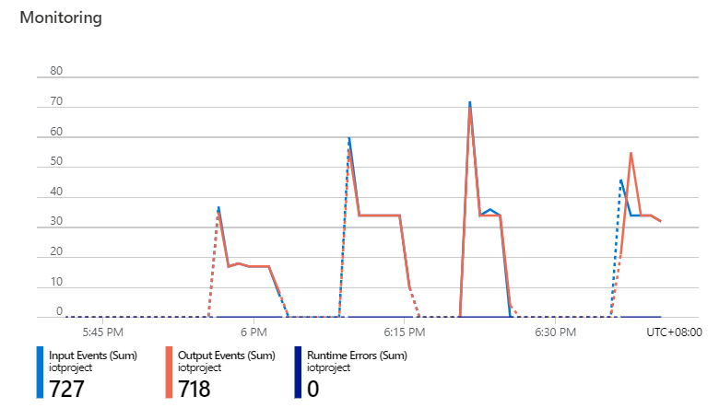

Figure 10 Real-Time Metrics from Azure Stream Analytics

The field parameters obtained are tabulated in Table 3. These parameters are added dynamically as a new row in the dataset “realtimesensor” of Power BI during streaming.

Table 3 Table Summary of sensor data in Power BI

|  |  |  |
| --- | --- | --- |
| **Dataset Name** | **Field** | **Type** |
| realtimesensor | ConnectionDeviceGenerationID | Text |
| ConnectionDeviceID | Text |
| CorrelationID | Text |
| Enqueued Time | Date/Time |
| Humidity | Decimal Number |
| MessageID | Text |
| Temperature | Decimal Number |

# **Data Visualisation**

# **VR**

The add-on of Autodesk Revit named “Prospect”, which is developed by IrisVR will be used for VR visualisation, the model data in BIM360 can be opened in Revit locally and the model will be converted for VR visualisation by using this add-on. It can create a narrative for the VR experience which is in 1:1 scale. Besides, Prospect is the only one that includes all utility features such as measurement, mark-up, snapshot, section view and object information in a single add-on compared with others in the market (Huang & Odeleye, 2018) and it provided free-trial for 14 days, so it has been chosen for this study.

The immersive VR headset Oculus Quest will be used for this study. It is a completely wire-free, PC free and with all the sensors built-in. The specification is summarised in Table 4.

Table 4 Specification of Oculus Quest

|  |  |
| --- | --- |
| Display panel | OLED |
| Display resolution | 1440 x 1600 per eye |
| Refresh rate | 72Hz |
| CPU | Qualcomm Snapdragon 835 processor |
| RAM | 4GB RAM |
| Battery | Lithium-ion battery with 2-3 hours playtime, depending on what you are playing |
| Degree of Freedom | 6 degrees of freedom head and hand tracking |
| Controllers | Two touch |
| Weight | 571g |

# **Dashboard**

As Power BI can get data from a large number of source such as Azure SQL database and Streaming Analytics after the connection has been set up, a dashboard created by Power BI will be used to visualise the construction performance data and sensory data. Data visualisation techniques such as charts, tree diagram has been used to tell the story of the data in this study. The charts and tree diagram would be created automatically once the data has been dragged and dropped onto the palette.

Also, whenever the data has been updated in the data source, one can just click the refresh button in Power BI to make a new query to update data. It also supports publishing as a report to the online workspace by Microsoft and it can be embedded into other websites such as BIM 360, which enhance the integration with the CDE.

A local dashboard file stored at this Github link[4] is attached for reference.

# **Connectivity**

Forge API by Autodesk is used to demonstrate the connectivity feature of the Control Room. It comprised of multiple APIs for retrieving different kinds of data for a specific group of tasks related to the Autodesk cloud ecosystem. The data such as model data, checklist, issues can be further developed for automated processes, workflows, and data visualisation.

A web-based viewer application[5] has been developed which makes use of the Forge API to retrieve the model data from sources like BIM 360 to the graphics rendering engine by Autodesk, which is a WebGL-based, JavaScript library for 3D and 2D model rendering. It is also a client-side library, based on pure HTML5 and JavaScript, Node.js environment has also been used.

First, an account should be created on Autodesk Forge for developing applications, there are different kinds of API[6] such as BIM 360 API can be selected when developing the applications. a Client ID & Secret can be obtained after the application has been set up. Second, the Client ID & Secret should be set to the environment variables of Node.JS environment to connect to the Autodesk Forge API services with the time of running the express server.

This application provides a way for the external stakeholders and non-technical persons (e.g. public) to read the BIM model data, which allows them to get the rich information from the building with the 3D models. The script is attached in Appendix 3. Since this viewer application required the login name and password of BIM 360 to access to it, for security reason, a video demonstration will be used to show how it works instead of deploying the web-application on the internet in this study.

# **GitHub Repository**

All the script developed can be found on the Github[7] page of this study.

# **Result & Discussion**

The result focuses on the evaluation and how do the Control Room’s features to achieve effective information management, insightful data visualisation and data connectivity to external applications based on the case study of residential house project.

# **BIM360**

# **Document Management**

The module “Document Management” provides ways to identify the change of information effectively. In the case study, the structural team members can find out what modification has been added in the model file by the architectural team, they can compare the versions of the model and all the additional features will be highlighted as Figure 11. The features which are highlighted in green are the additional elements added by other team members and the part highlighted in yellow indicate the building elements that have been modified.

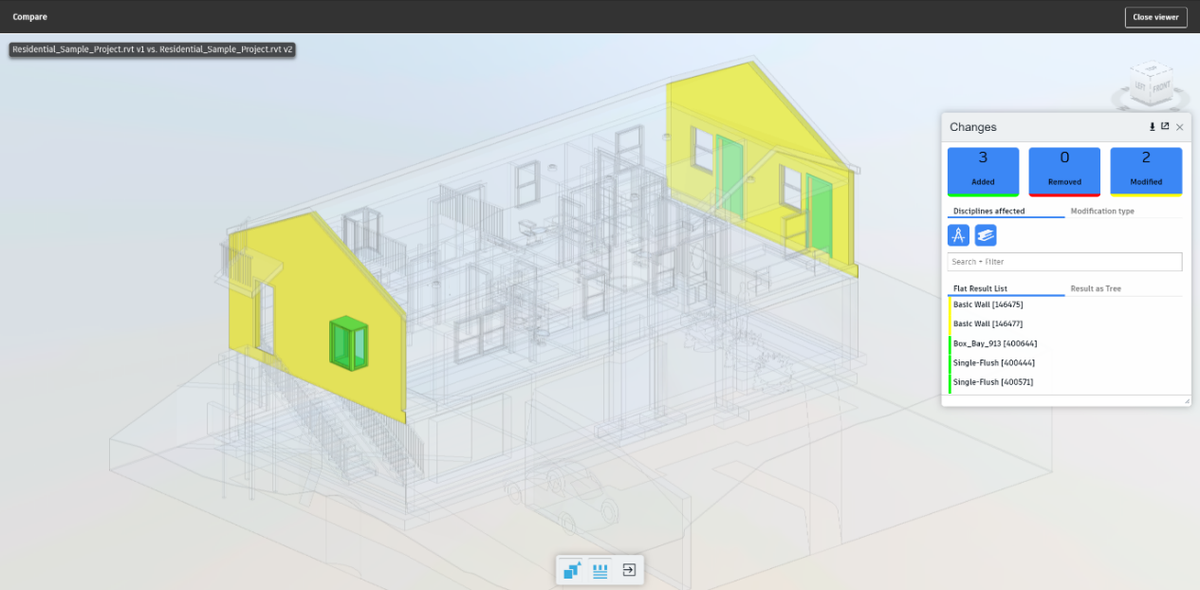

Figure 11 Comparing the difference between models by BIM 360 Document Management

Besides, it shows that the quality assurance process on the document can be digitalised to enhance its integrity. The workflow approval function is a set of step-by-step requirements that the team members should fulfil to make sure the quality of documents like BIM model fulfils certain standard to be approved.

For example, the structural engineer has identified the changes of the model by architect and added the respective structural elements to support the architect’s change, he would like to submit the updated model to his designated team members to review, he can select the model and choose the desired workflow based on different requirement and assign to the manager for review. An email notification window will be automatically sent to the manager afterwards. Then, the reviewer can make mark-ups and add comments to the model. And it can be sent back to the project engineer for amendment and the workflow only can go to the next step only when all the comments have been resolved.

This function ensures the quality of the information that it should be compromised for going to the next step and no need to spend extra time to return to the previous step to re-do the works under the traditional working practice as there was no strict workflow approval procedure. Also, it has recorded who have already received the notification to review the document and who need to answer the queries, so it pushes the team members to act on time to increase the productivity of works.

# **Design Collaboration**

The “Design Collaboration” module provides a way to enhance collaboration with different team members. For example, the structural engineer has modified the model with extra structural elements such as beam, columns and walls based on that model. Once they have completed the modification, the structural engineer can synchronize and publish the model data to the BIM 360 for other teams. On the web-platform of BIM 360, the structural engineer can create a package in the timeline as shown on Figure 12 so that the packages can be shared to other teams to consume this model and keep on modifying it.

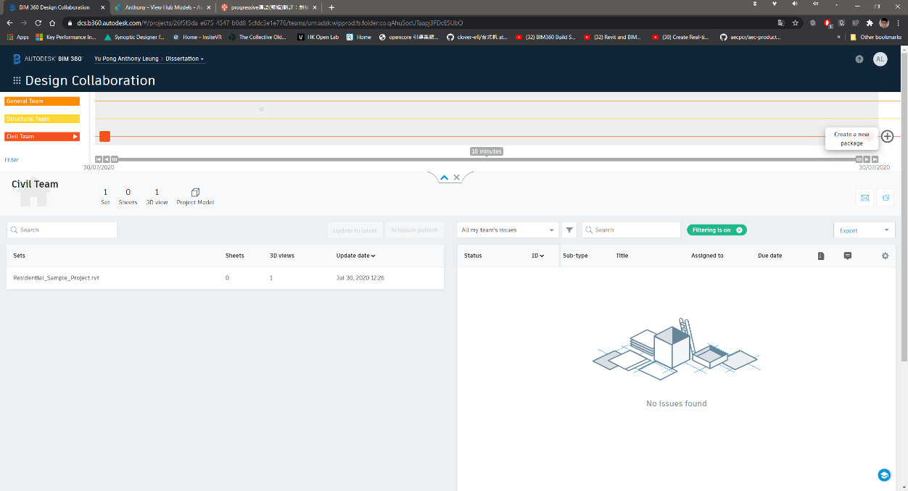

Figure 12 Overview of BIM 360 Design Collaboration Module

This design collaboration loop function provides a set of collaboration procedure to achieve a continuous and smooth handover of the model data between different team members.

# **Project** **Management**

The “Project Management” module provides a way to keep the RFI record clearly between different team members. For example, the structural engineer discovered the chimney wall outside the house will conflict with the structural wall inside the building and they would like to ask relevant teams such as the architectural team whether it is possible to relocate the chimney wall. The structural engineer can issue an RFI as Figure 13. The structural engineer can also add a push pin in the model to let the architect understand the situation clearly. Once it is submitted, the architect will be notified to make his decision automatically. All of these have recorded on the module and no need to spend extra time to search loads of email like the traditional practice to keep track of the status of the RFI.

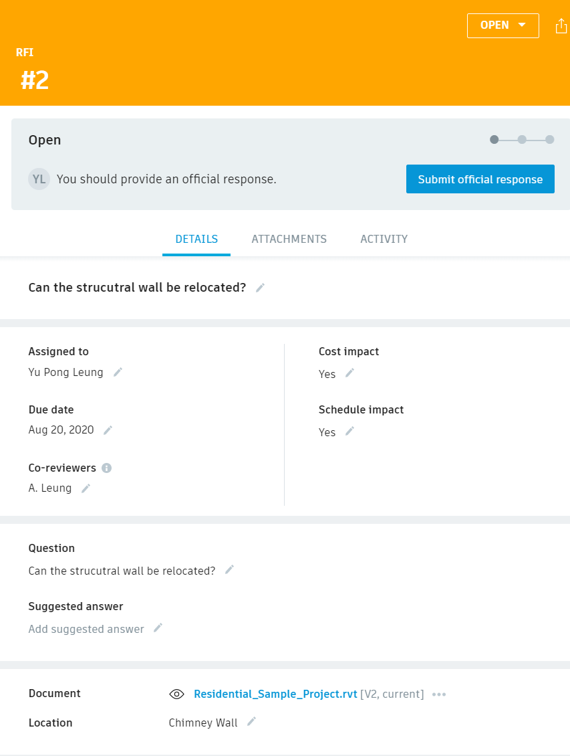

Figure 13 RFI form from BIM 360

# **Limitations**

The digitalised workflow approval and RFI functions by the first two modules set a good illustration of how effective collaboration and information management can be achieved. However, the “design collaboration” module is a bit complicated and it created multiple model data files which may lead to confusion. For example, after the publishing of the model data by one team member to the BIM 360, the model will be saved in the folder named “WIP (Work in Progress) folder” on the BIM 360, which is created automatically under the work breakdown structure of the design collaboration module. Besides, as the user need to create a package to share to other team members, the model data will be saved automatically in folder “Shared” after it is confirmed to share to other team members for consuming. And finally, after the model has been consumed, the model will be saved in the folder named “Consume”. As a result, multiple model data files have been created by using this design collaboration loop concept and it may make confusion to the beginners that they do not understand which model they should be used to work with if they are not familiar with the design collaboration concept.

# **Recommendation**

If the Control Room want to make use of such kind of features, series of training should be provided from project engineers , mangers to directors. Since the effectiveness of the collaboration platform can only be achieved if all the project team members able to use it, if there is

# **VR**

# **Project Perception**

The VR visualisation gives a great perception of the construction environment for multiple team members. First, the residential house model data has been parsed with the software “Prospect”. Different team members can either fully immerse in the 3D model data with the VR headset (right of Figure 14) or visualise the 3D environment with the computer (left of Figure 14). It gives a great perception for the project team members especially the newcomers to understand how the construction environment would be instead of imagination from the traditional drawings. As it is not uncommon that there are many newcomers ranged from workers to engineers to join a typical construction project every working day, and they need to understand the project as fast as possible to work with productivity. As a result, the VR visualisation plays an important role form them to understand the construction environment in a faster way.

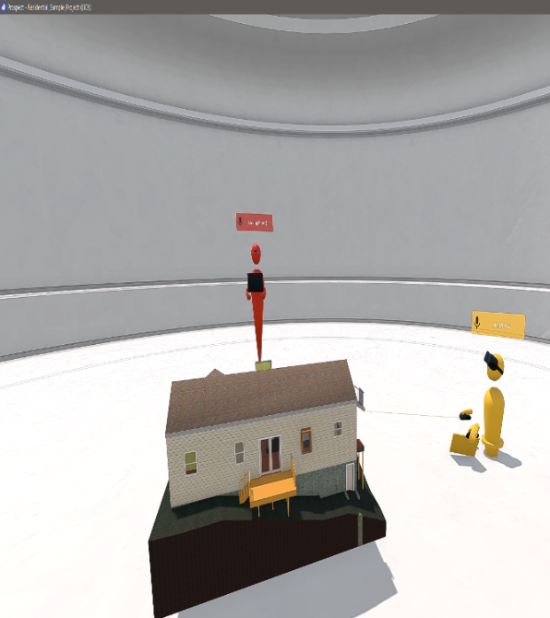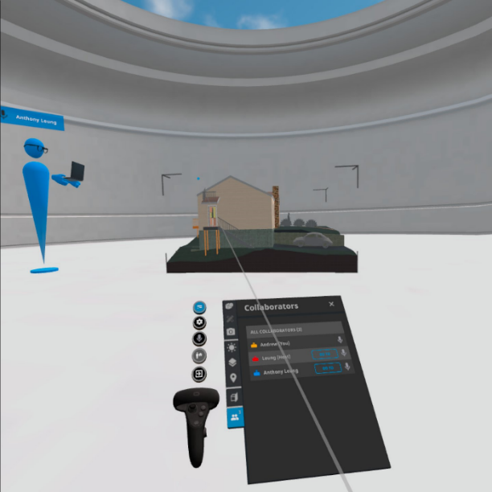

Figure 14 Different Team member immerse in a 3D environment

Team members can also carry out VR remote meeting to review the modification need from other teams. For example, they can make use of the utility features such as measurement, mark-up tools, object details and a sectional view for the user to present their idea during the remote meeting effectively. The building service engineer (blue) can use the mark-up tool to add annotations and comments on the ceiling of a specific room so that the structural team member (yellow) can adjust the setting out of the structural beam to avoid crashes with this building services utilities during VR inspection. The video link of the demonstration is …

After they have agreed how they would modify their design and the construction sequence in the VR inspection, team members can have a clear understanding of the need of other members. They can amend their respective data model and combine with the use of design collaboration module in BIM 360. As a result, different team members can modify the model effectively and avoid crash of elements, which greatly increases productivity. This form of remote working is useful if the team member cannot access to office and site.

# **Safety Hazard Identification**

Besides, it is useful to identify locations with safety hazards. As the user can visualise the model from it very beginning to the completion stage. All the safety hazards during the construction can be identified and find out the exact locations with the high risk of safety deficiency such as confined space, locations which easy to fall from a height. For example, the balcony at the west evaluation of the residential house which is above ground for 2.45m meters and at the edge location as Figure 15, which is highly susceptible to the hazard of falling from height. This can help the managers to arrange special training for workers such as working on height and pay more attention to this location during the construction of the balcony.

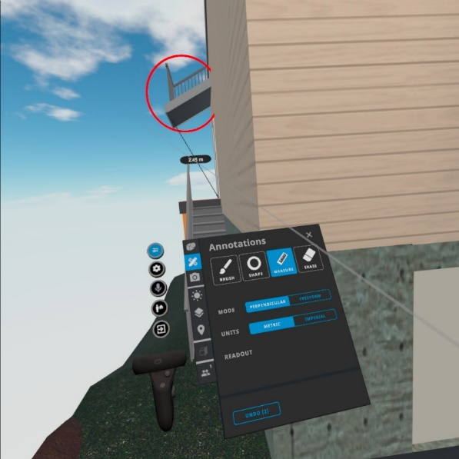

Figure 15 Identifying Safety Hazard

# **Limitations**

The subscription cost is not competitive enough and often exists as a separated plug-in or services rather than integrated with the collaborate tools. It made individual need to pay extra cost to buy this service to use, which lower the motivation for the construction professionals to adopt this technology. According to two services providers like Prospect by IrisVR and “the Wild”, their monthly subscription is about USD 225 and USD 295 respectively, which is not an affordable price for some small size company to adopt this solution.

Besides, the compatibility of the add-on of “Prospect” should be improved. For example, one must need to open the local desktop software Autodesk Revit to load the model data from the cloud BIM 360, and use the VR add-on in Revit to transfer the BIM model data its external VR software “Prospect” to parse the model data so that we can visualise the immersive VR environment on the external software which is shown on Figure 16. To make it more user-friendly, it should be integrated into the cloud platform of Control Room (such as BIM 360), so that when all the project team members access to the cloud platform, they can open the model file and then press one button to access the immersive VR environment for a walkthrough and remote meeting immediately rather than installing external software and so many steps to start with the visualisation with VR.

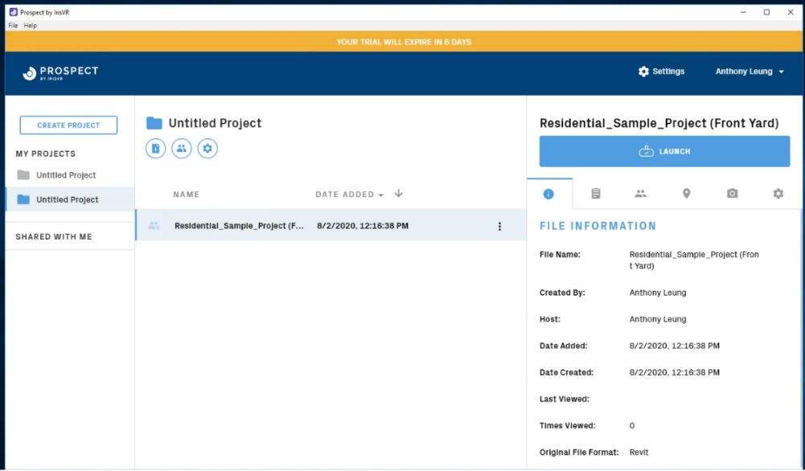

Figure 16 Overview of Prospect

Besides, as the construction of the residential house project does not involve much complex structure, the benefits of using VR cannot be fully illustrated. For other types of project such as the construction of water treatment plants, it involved complex configuration of the layout shown as Figure 17 for the structure to treat the water and transfer it from one treatment building to another. As a result, the VR can give a great perception of how the structure looks like after the construction and visualise the construction sequence so that it can give a great perception to the project members and reduce faults to construct such kind of complex structures.

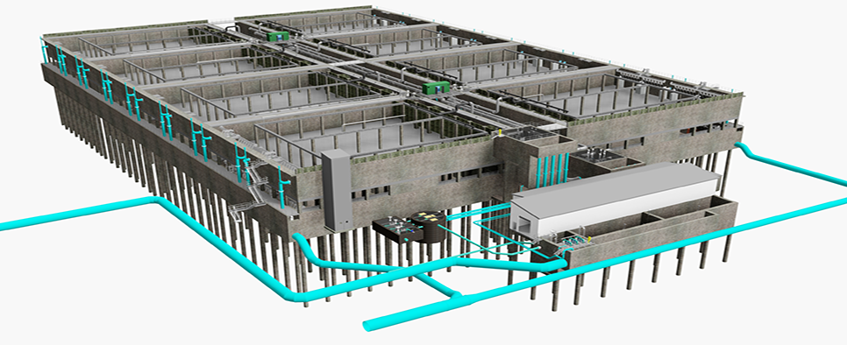

Figure 17 Layout of Water Treatment Structure of a project[8] located in Liverpool

# **Dashboard**

# **Identify Insight from Safety Record**

In the first dashboard (Figure 18), we can identify that the total number of accidents is about 139 and 1 fatality for the construction of the residential house from 2016 to 2020. The trend of the number of accidents is decreasing across the years and the basement with the highest number of accidents. One can choose whatever categories under different indicators such as “Severity”, “body part”, “main activity”, “Risk Category” and “Injury Type” so that the total number of fatalities, incidences and the number of accidents across different years will be changed. It is easy to identify that most of the accidents belong to the activity of concreting, category of risk with slip or trip on the same level, workers suffering from body parts such as leg and the severity of most of the case is low.

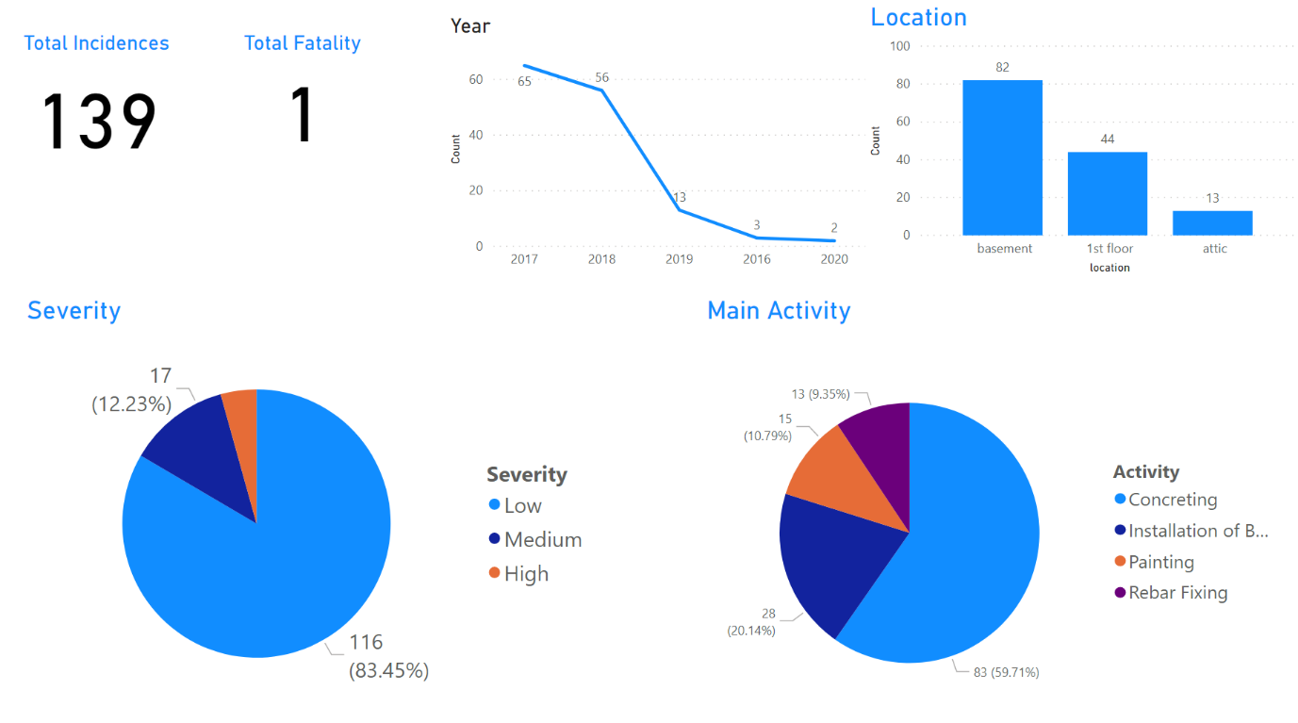

Figure 18 Dashboard Visualisation by Power BI - Overview

According to these messages provided via this dashboard, the project managers should pay more attention to the activity like concreting and the location of the basement. The managers can make an investigation to see the causes lead to the workers suffering from a high risk of accidents in the basement when concreting. Besides, managers can provide more personal protection equipment to protect the legs of the workers.

Besides, the second dashboard uses a tree-level diagram, which shows the root of how to constitute the number of accidents. The tree diagram (Figure 19) has separated into different levels, the first one is “nature of injury”, the second is “activity”, the third is “location” and the last one is “no of days lost”. For example, when we selected one of the categories under the first level “severity”, then the number of accidents will be separated into different groups under the second level “location’”. And then it will separate into different groups under the third level “activity”, when we click one of the group, the number of accidents will be separated in different groups again under the forth level ‘body part’, so that we can identify the number of accidents based on a different level of a specific root.

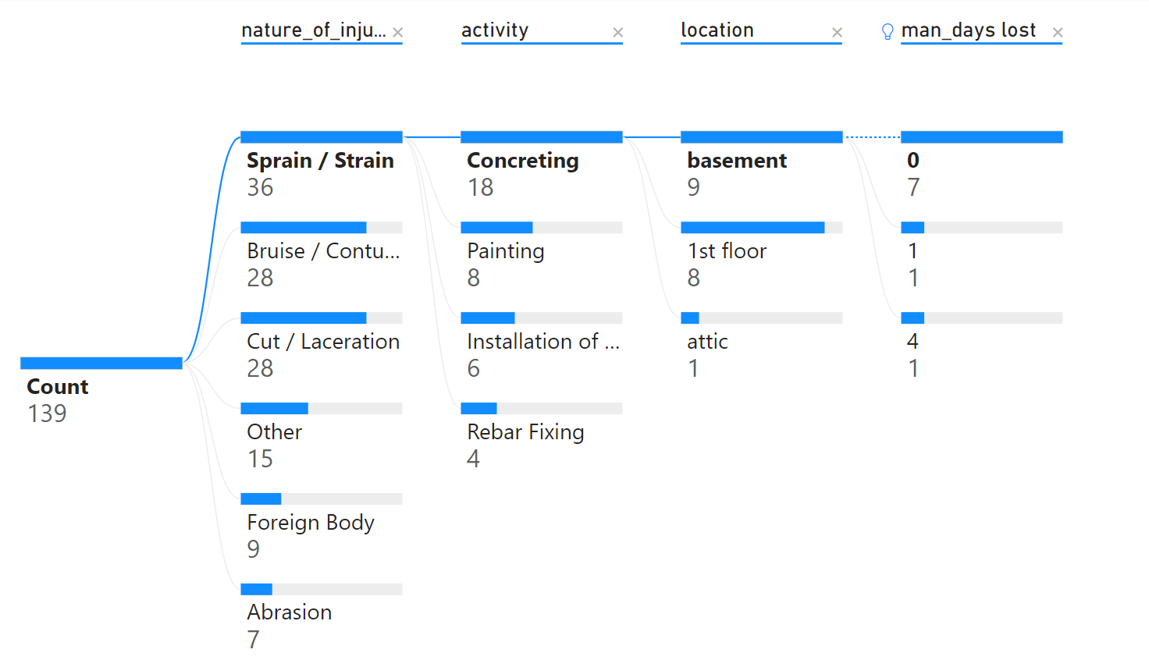

Figure 19 Dashboard Visualisation by Power BI – Tree Diagram

The Project Managers can easily identify which construction activities at its respective location to cause different types of the nature of injuries and the productivity lost. It gives a chance for the project manager to identify each nature of injury concentrated on what activities and where its location. It can give an idea for the project manager to arrange the manpower on different locations to avoid the risk of manpower lost and enhance the productivity and control the project cost properly.

# **Monitoring the Working Environment**

The real-time sensory data has been visualised with line chart in Power BI dashboard. Overall, 88 data points for both temperature and humidity were collected on 22 Aug 2020. The variation of the temperature and the humidity of the working environment has been captured on Figure 20. Although the variation of the data of this result was not very large enough, which is around 32-33 oC temperature and 64% humidity during operation, it shows the ability that the project members can make use of the sensory data to keep monitoring the working environment of the workers in real time. If the temperature and humidity achieved a level which is not suitable for the workers to work, **the project engineer can ask the workers to take a regular break immediately.**

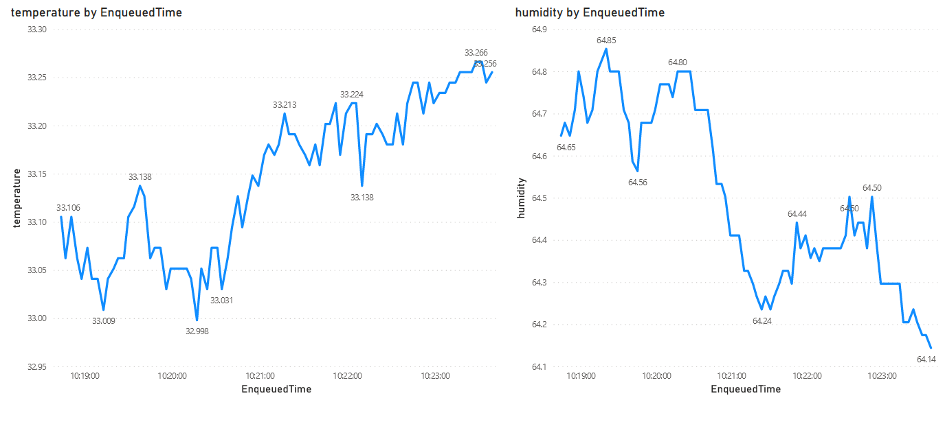

Figure 20 Line Chart Visualisation of Sensory Data by Power BI

# **Limitation**

The Power BI is a great platform to present the data to give insight, pattern and abnormality. However, based on the availability of the dataset, the author cannot find data to establish a KPI for monitoring the construction performance. The maybe due to as the AEC industry is complicate, different construction companies will have their standard and indicators to report the project safety, progress related issue and workflow for quality assurance process. As a result, there is no common objective benchmark for the AEC industry to compare the construction performance such as construction KPIs. The AEC industry should try to agree with a set of KPIs so that the construction performance of every company can be compared based on these KPIs and the dashboard features of the Control Room system can make use of this common standard for comparison.

Besides, the project manager should not misattribute causality when comparing elements on the dashboard. The dashboard result shows that most of the accident record concentrated on the location of the basement while the number of an accident on the attic is the lowest, but it just means the location of the basement is more likely to have an accident compared with attic based on the old record, the project managers should also think about the nature of the construction works whether it is different from the basement so that the old record cannot be as the sole guideline to set up safety policy and resource allocation to mitigate the problem.

# **Recommendation**

For the use of sensory data, a more accurate result of the working environment can be achieved by installing multiple sensors at a different location so that the environment data would not be based on one location. However, it would cost much higher and the project manager may be no motivation for this technique if the sensory data cannot give a big return. Apart from that, a dashboard is not the best way to visualize the sensory board, it would be much for useful if it can be visualized in the VR environment so that it gives a much better perception of the status of the working environment during remote working. However, it involved high technical knowledge and still developing for practical usage recently.

# **Connectivity with External Applications**

This viewer application (shown as Figure 21) developed with Forge API can provide external access for the non-technical users such as the public or the client, which enhance the transparency of the project delivery. A video demonstration has been uploaded on this link[9]. The users can use the toolbar below the 3D model for the users to navigate the model and be familiar with the building information stored in each building elements. For example, the client of this project can utilize this viewer to gain a better perception of the interior environment before it has constructed and got the detailed information provided by the 3D model. Real-time sensory data can also link to this model such that the public can understand how the construction works impact to the nearby environment.

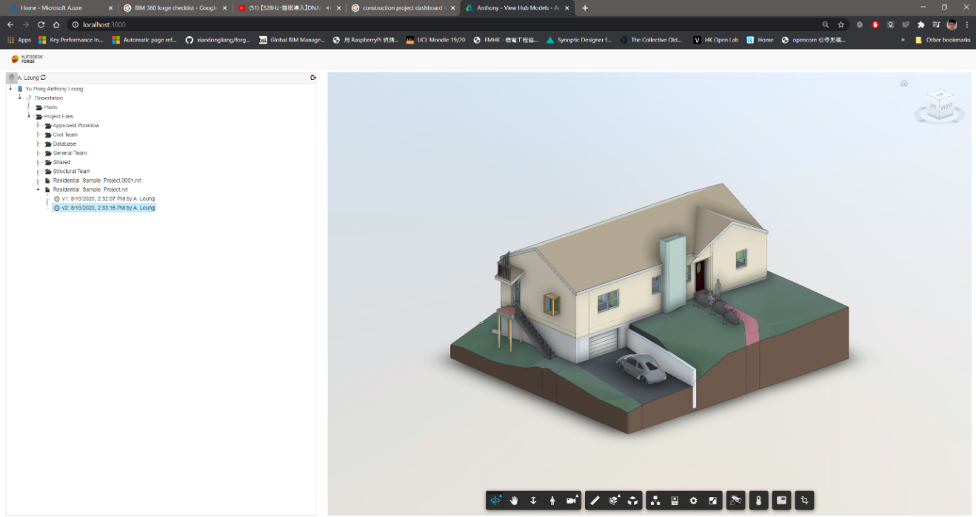

Figure 21 Overview of Viewer Application

# **Challenges**

Due to some technical challenges, the author is only able to develop a simple viewer application to demonstrate the connectivity feature of the Control Room. Although Autodesk already provides documentation to develop different applications on the internet, it is highly fragmented and not easy to start with. For example, the author originally wants to integrate the sensory data into the BIM model data to provide more information for visualisation. However, manual coding to integrate the sensory data in the viewer application[10] required a higher level of programming knowledge, such as using JavaScript library React framework to build it, which cause a steep learning curve for a typical construction-related user to learn for it.

# **Recommendation**

Regarding this issue, it is suggested that a visual programming interface which is similar to the “makecode[11]” for developing applications for micro bit should be provided on the API feature of the Control Room so that the user can more easily to customise on how to push data to or get data from other external applications. Since the technology adoption in the AEC industry is not strong enough and not many construction professionals with IT background, a visual programming interface can set a good starting point for the construction professional to customise their use.

Besides, the connectivity feature plays an important role to ensure all the project data can be more integrated and for further analysis. As there are different external proprietary mobile applications used by contractor companies to record the productivity of the frontline workers, share construction information like mark-up drawings, progress photos and issues tracking in the construction site. The Control Room should have the connectivity to get and process the data from these external applications such that these data can be gathered to the common data environment of the Control Room for storage and visualisation. The project data should also be connected to other external cloud servers for processing such as Machine Learning algorithm, which makes the Control room functions scalable and expands its computation power.

# **Day-to-Day Routine of Control Room**

Although some of the Control Room features cannot be demonstrated as expected due to some technical challenges, it shows the ability it could be and its improvement. Day-to-day operation of the Control Room on the residential house design and build project can be illustrated as follows:

First, the engineer can access the web-based BIM 360 platform to understand the status of different workflow requested for approval, RFI submitted by other team members at ”Project Home” page. Then he can use the local software Revit to access to the BIM model data stored in BIM 360 to review and modify the model to resolve the issue raised. If the engineer is not sure whether his modification on the model can fulfil the need by the architect, they can hold a VR remote meeting to present themselves in the model, they can discuss together in a 3D immersive environment to comprise a design which can fulfil the need of both teams. It can increase productivity and avoid re-do works. During the construction stage, the engineer can use the sensory data to realise the environment condition of the construction site to check whether the working environment is suitable for working. If the temperature always above the threshold of working, the engineers should ask the workers to take regular breaks to maintain their health to work.

Apart from the project engineers, the project managers and project directors can make use of the dashboard to oversee the accidents record at the construction site to identify which locations, construction activities will cause high safety risk so that they can set up strategies to mitigate the safety deficiency such as provide extra PPE when concreting at basement and set up goals to maintain the safety record and ask the project engineer to keep on monitoring it. They can also use the VR visualisation with BIM model data to conduct a walkthrough in an immersive 3D environment for a site inspection to identify any locations with high risk during construction and construction constraints to facilitate their planning of resources and cost of the project.

Besides, the engineer can also access to the control room to get more detail information such as the workers’ productivity, progress photos from the construction site which captured by other external applications. He can also push the information he wants to the cloud server which with high computation power.

Apart from the working professionals, the general public and client can also access to the online viewer application to understand the progress of the construction works, the building information and how the construction works would affect the environment at the real-time.

The video link shows the day-to-day operation:

# **Future Development of the Control Room**

Since time is the constraint of this study, the author cannot explore other features such as prediction and automation of the Control Room, which is suggested from literature (Zhuang et al., 2018). In the future study, it is possible to evaluate the prediction features such as using the progress data with the machine-learning algorithm to identify any pattern of the project tasks will highly possible that lead to pushing back and over budget if they are delay. It can give a better insight for the project manager to allocate the resource with more certainty. Similar solution currently available on the market is by nPlan[12].

Another possible area of automation to explore could be making use of sensor data to enhance the health and safety of workers. Once the sensory data indicate that the environmental condition is not suitable for working, the control room can help the managers to send out messages to the mobile phones front workers automatically. Besides, a camera for object detection can be installed on the sensor, if it is detected that the workers do not wear the personal protection equipment (PPE) properly or without wearing PPE, the control room can also notify the workers automatically and warn them.

# **Conclusion (300 words)**

(Link to Intro, LR, Digital Twin!!!, We set out to explore x and learnt y )

This study does two things: explore the features of the Control Room in the AEC industry; and explore how these features to improve project delivery and the improvement based on the available solutions. It is identified that information management, data visualisation and connectivity play an important role in the Control Room’s feature. With the help of currently available solutions, BIM 360 and Microsoft Azure Cloud are used to demonstrate information management, Power BI and IrisVR for data visualisation and Forge API to illustrate the connectivity. All these applications combined to build the Control Room.

By using a case study of constructing the residential house, the Control Room features have been evaluated as follows. It shows that the document management and project management modules set a good illustration of how effective collaboration and information management can be achieved but the design collaboration should be simplified. For Data Visualisation, VR can help to increase the project perception, provide remote meeting platform and identify safety hazard but its subscription cost should be more competitive to motivate more companies to use it while dashboard can help project managers to identify which construction activities at its respective location to cause different types of the nature of injuries and the productivity lost. The environmental data can also be visualised with the dashboard in real-time. For connectivity, a viewer application developed by forge API, this application can enhance the project transparency and it is recommended that these features should be simplified such that it is easier to learn and more useful applications can be developed.

Future studies can be focused on the prediction and the automation features which can facilitate the project planning and improve the health and safety for the workers.

# **Reference**

Alizadehsalehi, S., Hadavi, A., & Huang, J. C. (2019). Virtual reality for design and construction education environment. *AEI 2019: Integrated Building Solutions - The National Agenda - Proceedings of the Architectural Engineering National Conference 2019*. https://doi.org/10.1061/9780784482261.023

Bennett, S. (1993). A History of Control Engineering 1930-1955. In *A History of Control Engineering 1930-1955*. https://doi.org/10.1049/pbce047e

Boje, C., Guerriero, A., Kubicki, S., & Rezgui, Y. (2020). Towards a semantic Construction Digital Twin: Directions for future research. In *Automation in Construction*. https://doi.org/10.1016/j.autcon.2020.103179

Bolton, A., Butler, L., Dabson, I., Enzer, M., Evans, M., Fenemore, T., & Harradence, F. (2018). The Gemini Principles. *University of Cambridge, UK 2018*. https://doi.org/10.17863/CAM.32260

Brandon, J. (2020). *VR is the future of remote working*. https://www.techradar.com/news/vr-is-the-future-of-remote-working

Changali, S., Mohammad, A., & Van Nieuwland, M. (2015). The construction productivity imperative. *McKinsey Quarterly*.

Chhaya, M., Juneja, S., Smaje, K., & Sukharevsky, A. (2020). *Driving digital change during a crisis : The chief digital officer and COVID-19*. Mckinsey Digital. https://www.mckinsey.com/business-functions/mckinsey-digital/our-insights/driving-digital-change-during-a-crisis-the-chief-digital-officer-and-covid-19

Cosgrave, E. (2017). The smart city: challenges for the civil engineering sector. *Proceedings of the Institution of Civil Engineers - Smart Infrastructure and Construction*. https://doi.org/10.1680/jsmic.17.00012

Freina, L., & Ott, M. (2015). A literature review on immersive virtual reality in education: State of the art and perspectives. *Proceedings of ELearning and Software for Education (ELSE)(Bucharest, Romania, April 23--24, 2015)*. https://doi.org/10.12753/2066-026X-15-020

Global Construction Survey. (2019). Global Construction Survey 2019. *KPMG International*.

Harrison, C., Eckman, B., Hamilton, R., Hartswick, P., Kalagnanam, J., Paraszczak, J., & Williams, P. (2010). Foundations for Smarter Cities. *IBM Journal of Research and Development*. https://doi.org/10.1147/JRD.2010.2048257

HSE. (2019). Work-related stress , anxiety or depression statistics in Great Britain , 2019. *Annual Statistics*.

Huang, Y., & Odeleye, T. (2018). Comparing the Capabilities of Virtual Reality Applications for Architecture and Construction. *Ascpro0.Ascweb.Org*.

Institution of Civil Engineers. (2018). Project 13 Blueprint. In *Institution of Civil Engineers*. http://www.p13.org.uk/wp-content/uploads/2018/06/P13-Blueprint-Web.pdf

Jarrett, H. (2020). *Rise of the Digital Twin: How Lessons Learned from NASA Are Changing the Way Supply Chains Are Managed*. https://info.expeditors.com/horizon/rise-of-the-digital-twin

Lara, A. P., Da Costa, E. M., Furlani, T. Z., & Yigitcanlar, T. (2016). Smartness that matters: Towards a comprehensive and human-centred characterisation of smart cities. *Journal of Open Innovation: Technology, Market, and Complexity*. https://doi.org/10.1186/s40852-016-0034-z

Levine, T. (2016). *Using Communication and Collaboration Technology to Keep Construction Projects On Schedule and On Budget*.

Li, X., Yi, W., Chi, H. L., Wang, X., & Chan, A. P. C. (2018). A critical review of virtual and augmented reality (VR/AR) applications in construction safety. *Automation in Construction*. https://doi.org/10.1016/j.autcon.2017.11.003

McKinsey. (2015). The MGI Industry Digitization Index. *McKinsey Global Institute*.

McKinsey & Company. (2017). Reinventing Construction: A Route To Higher Productivity. *McKinsey & Company*.

Microsoft. (2020). *Azure Cloud Services*. https://azure.microsoft.com/en-us/overview/what-is-cloud-computing/

Mohd Nawi, M. N., Baluch, N., & Bahauddin, A. Y. (2014). Impact of fragmentation issue in construction industry: An overview. *MATEC Web of Conferences*. https://doi.org/10.1051/matecconf/20141501009

Richard, J. D. (2018). *Why Does the Construction Industry Love Silos?* https://medium.com/@rdriscol/why-does-the-construction-industry-love-silos-add6175dca9b

Stergiou, C., Psannis, K. E., Kim, B. G., & Gupta, B. (2018). Secure integration of IoT and Cloud Computing. *Future Generation Computer Systems*. https://doi.org/10.1016/j.future.2016.11.031

Toasa, R., Maximiano, M., Reis, C., & Guevara, D. (2018). Data visualization techniques for real-time information - A custom and dynamic dashboard for analyzing surveys’ results. *Iberian Conference on Information Systems and Technologies, CISTI*. https://doi.org/10.23919/CISTI.2018.8398641

Voordt, T. J. M. van der. (2017). *Benchmarking of Workplace Performance*.

Xu, S., & Luo, H. (2014). The information-related time loss on construction sites: A case study on two sites. *International Journal of Advanced Robotic Systems*. https://doi.org/10.5772/58444

Yi, Y., Yan, Y., Liu, X., Ni, Z., Feng, J., & Liu, J. (2020). Digital twin-based smart assembly process design and application framework for complex products and its case study. *Journal of Manufacturing Systems*. https://doi.org/10.1016/j.jmsy.2020.04.013

Zhuang, C., Liu, J., & Xiong, H. (2018). Digital twin-based smart production management and control framework for the complex product assembly shop-floor. *International Journal of Advanced Manufacturing Technology*. https://doi.org/10.1007/s00170-018-1617-6

# **Research Log**

|  |  |  |  |
| --- | --- | --- | --- |
| **Date** | **Task** | **Challenges** | **Solutions** |
| 02/08-  24/08 | Writing |  |  |
| 01/08-  15/08 | Set-up VR headset and Prospect Account  Retrieve data from SQL server to http endpoint | NA  Many steps | NA  -Use Azure App service to deploy the apps |
| 22/07 | Second meeting with the supervisor | Many technical challenges | Narrow research focus |
| 01/07-  21/07 | Writing |  |  |
| 12/06 -17/07 | -Activate BIM360  -Set up Forge account  -Set-up Raspberry Pi  with Azure Services such as IoT Hubs, Stream Analytics  -Learn Power BI | -Power BI cannot integrate all the things in 1 single platform (BIM360)  -VR-plugin in BIM360 has not been installed, but able to visualize it locally in Revit, no response for the free-trial for the plug-in in BIM360    -Sensor data cannot show inside forge viewer | -Publish the Power BI dashboard to display in BIM 360 with log-in credentials with Microsoft instead of publishing it publicly  -Transfer sensor data to Power BI directly by Azure Streaming Analytics  -Use local plug-in of VR in Revit |
| 10/06 | First meeting with the supervisor | With research focus but not sure what specific things can do | Think about:  Why we visualize in that way  Why we need this info, how it benefits to the place.  Build Project Plan, Github |
| 31/05 – 14/06 | Learn to use Raspberry Pi | To understand how to connect the sensor to the micro-controller | Google |

# **Appendix**

1. Design and Build Project means that design and construction ongoing at the same time, reference: [https://en.wikipedia.org/wiki/Design–build](https://en.wikipedia.org/wiki/Design–build%20)
2. Reference Link: <https://projectdataanalytics.uk/past-events/projecthack5-output>
3. Reference: <https://en.wikipedia.org/wiki/Request_for_information>
4. Link: <https://github.com/ypleungaa/Control_Room_AEC_Industry/blob/master/Code/Dashboard/Safety/safety_dashboard.pbix>
5. Documentation: <https://learnforge.autodesk.io/#/tutorials/viewhubmodels>
6. All the available API can be explored on <forge.autodesk.com>.
7. Link: <https://github.com/ypleungaa/Control_Room_AEC_Industry>
8. Project details: <https://www.atkinsglobal.com/en-gb/projects/liverpool-wastewater-treatment-works>
9. Link:
10. Reference: <https://github.com/Autodesk-Forge/forge-rcdb.nodejs>
11. Microsoft’s MakeCode editor makes use of the colour-coded blocks for the users to start programming and get creating with the BBC micro:bit. <https://makecode.microbit.org/>
12. https://www.nplan.io/